1. Install xampp

2. Copy the "cart" folder into xampp > htdocs

3. Access http://localhost/phpmyadmin/

4. Create a database and name it "jager"

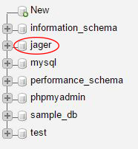

5. Click on created "jager" database and go to "Import" tab.

5.1 Click on “Choose File” button and select “jager.sql” file in “cart” folder.

5.2 Click on “Go”

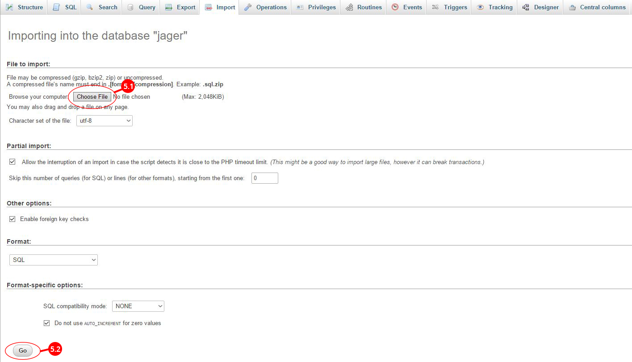

7. Go to cart > application > config folder and open “database.php” file in any code editor. (Netbeans, Atom, Sublime Text etc.)

8. Change “Username” and “Password” into your host “Username” and “Password”. If it is default keep it as it is.

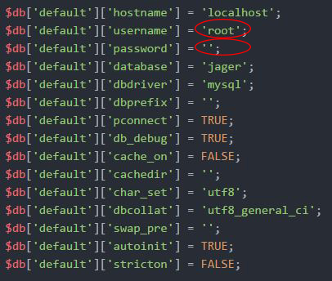

9. Access the system - <http://localhost/cart/>

9.1 Username – Thulara

9.2 Password -

10. Access the admin panel - <http://localhost/cart/admin.php/login/load_login>

10.1 Username – Thulara

10.2 Password -